# Guidance on dIP Measurement

Pan Feng, 15210720168@fudan.edu.cn

dIP is the distance between principal plane and the imaging plane. This parameter is defined as cameraDist in the program pixy_node.

As is shown in Fig. 1,

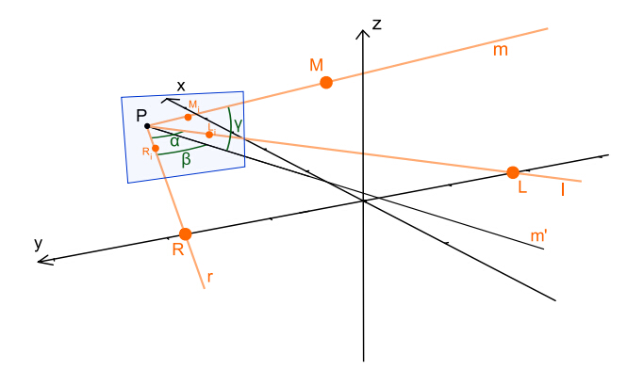

Fig. 1 Geometric measurement of the camera frame and local frame.

P is the position of the camera principal point and the blue screen is the imaging plane. We need to get the distance between principal plane and imaging plane so that we can calculate the three angles α,β,γ. So dIP is a very important parameter. But the parameter is likely to change along with the focal length or lens calibration parameters. If we have to change either focal length or lens calibration parameters during the experiment, we can use Matlab program to calculate this parameter again.

Then the following article is the guidance on how to use the Matlab program to calculate cameraDist.

1. set some parameter in the program, including screen length, screen width, and d_MO and d_LR.
2. use camera to take a photo of the markers, and note the actual coordinate of the camera.
3. comment the coordinate of LRMS with ‘%’ in the photo in Matlab code. Then write the coordinate in the program like the following picture

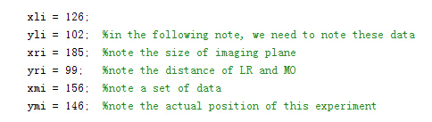

Fig. Comment this block before set new parameters.

1. set the start and end of cameraDist parameter and run the program

5. choose the most suitable number so that the coordinate of P is very close to the actual coordinate. And note the number as the cameraDist。

p.s. According to my own experience, the parameter cameraDist is between screen length and screen width. As for pixy, its screen length is 318, and screen width is 198. As a result, the cameraDist is between 198 and 318.